OFFICIAL COORDINATION REQUEST FOR
NON-ROUTINE OPERATIONS AND MAINTENANCE

COORDINATION TITLE: 13BON03 NDE lamprey flume IWW extension
COORDINATION DATE- 4 February 2013
PROJECT- Bonneville Lock and Dam – Washington Shore Fish Ladder
RESPONSE DATE- 14 February 2013 (FPOM)

Description of the problem- The Corps of Engineers (COE) is installing a prototype adult Pacific lamprey passage structure designed to improve lamprey passage at the Bonneville WA Shore north downstream entrance (NDE, see Figure 1). Construction was scheduled to be completed during the 2012-2013 in-water-work (IWW) period. Most of the system will be placed along the tailrace side of the south wall, between NDE and the north upstream entrance (NUE). In previous coordination (110412 BON) the Corps of Engineers indicated the need for an extension of the IWW period to 12 November through 28 February for the Washington Shore Fish Ladder, Powerhouse 1 priority, and extension of downstream bypass system outage. The requested November start date was intended to avoid a March outage of the ladder.

Current Columbia River flow conditions, dive support needs for Lamprey Flume System (LFS) construction, spillway repairs, and other maintenance work at Bonneville Dam will make it impossible to complete LFS construction within the coordinated IWW period of 12 November – 28 February. COE requests further extension of the IWW period to March 31, including the following operations:

- Extension of the IWW period through March 31 for the Washington Shore Fish Ladder:
  - March 1-11: Partial operation, including South Upstream and Downstream entrances (SUE, SDE) from March 1-11 (NDE and NUE will be closed). By March 1, close Cascades Island Fish Ladder exit and open Washington Shore Fish Ladder exit. Operate as many floating orifice gates (FOGs) as possible. Open entrances and FOGs should include sea lion exclusion gates. Construction during this period will involve use of a crane situated on a temporary platform over the NDE-NUE transportation channel (Figure 2) and may also include use of a floating platform/barge in the tailrace.
  - March 12-31: Full operation (NDE, NUE, SUE, SDE), but with limited construction activities on tailrace deck. Approved construction within 50 ft of fishway would include installation of the LPS components on the tailrace deck (Figure 3), handrails, and other relatively benign/quiet activities. Operate FOGs according to FPP.

- Continue Powerhouse 1 priority operation through March 15. Prior to that date, Powerhouse 2 units will be in and out of service to allow for safe dive operations. Specific dive dates and times are to be determined, but COE anticipates that dive operations will take up to 11 days (March 1-11); 16 hours per day, leaving 8 hours available for nighttime use of Powerhouse 2 units. Specific operations (minimum 2 days advanced notice) must be coordinated throughout the construction period to ensure dive safety. When Powerhouse 2 units are operated, main units on the south end of the powerhouse will be prioritized to provide attraction flow to SUE and SDE.

Fredricks expressed concerns about this item (original proposal was March 25). He would like to see PH2 priority after 15 March and operation of screened units only unless the B2CC is open. The fish passage season begins 1 March at Bonneville Dam. Anytime PH2 is operated after 1 March, there needs to be a bypass (see # 4 below). The B2CC is a bypass route. Fredricks does not want to see the B2CC turned on and off. Fredricks asked why the B2CC would be closed when flow is diverted to spill. Bettin said because the trigger hasn’t been met. Fredricks said he was ok with closing the B2CC to allow the barge to move as long as the occurrence is relatively infrequent.

- Delay operation of the DSM2 until March 12 and complete installation of STSs at Powerhouse 2 by March 15 This assumes returning DSM2 to service takes 1 day and installation of STSs takes 4 days.
February operation of PH2 is not an issue, as it is within the IWW period. FPOM said STSs could be installed in units at PH2, forcing them out of service until 15 March, if this would help get the DSM2 up and running by 15 March. Mackey clarified that BON could get screens in the week of 11 March and have everything up and running by 15 March; Tackley noted that this was factored in to the requested dates.

- B2CC operations –
  - March 1-11: The B2CC will be operated as needed to pass flow to accommodate dive operations for construction (daytime). It will also be opened anytime Powerhouse 2 units are operated to provide a bypass route for adult and juvenile fish. Depending on dive operations, this may result in continuous operation of the B2CC during this period. The B2CC may be closed occasionally to allow the floating platform/barge to move in and out of the Powerhouse 2 tailrace.
  - March 12-15: During this period, Bonneville Project staff will be bringing bypass systems back into operation. The B2CC will be opened anytime Powerhouse 2 units are operated to provide a bypass route for adult and juvenile fish.
  - March 15-31: Trigger for opening B2CC to be determined at FPOM on February 14.
Fredricks wants to see the B2CC operating from 1 March until 11 March. During the day (when PH2 units are OOS), the B2CC will be operated as part of spill. During the night, the B2CC will be operated if PH2 units are operated. Fredricks pointed out that for most of the time (during the day) we will need to pass flow via either the Spillway or the B2CC, so it shouldn’t matter from a generation standpoint.

15 March- DSM2 is operating, so could be used after that date to determine the steelhead kelt trigger for operating the B2CC. Lorz noted that the delay in operating the DSM2 means that the trigger date would likely be later than it would have been otherwise. Fredricks and Lorz would like to use a date for starting the B2CC. Fredricks’ updated kelt trigger memo suggests 18 March as the B2CC open date.

- If Powerhouse 1 capacity is fully utilized and Powerhouse 2 units are OOS for dive safety, water will be passed via the Spillway and/or the B2CC. COE will maintain 13.5 ft minimum tailwater elevation for chum salmon redds downstream of the dam. The COE will make best efforts to maintain TDG levels within State standards.

- If installation of the LFS is not completed during this IWW period, additional work may need to be scheduled in the late October - November time period. Considerations for this outage would include assessing potential delay of adult salmon and steelhead, taking advantage of low flows prior to chum salmon spawning, and avoiding impacts to Bradford Island Fish Ladder maintenance activities.
Fredricks said he cannot be in a situation of choosing between listed species. He is not concerned about TDG for chum in the fall, but the 105% cap is a state standard. Klatte suggested 28 October through 15 November. He said he would fine tune it by FPOM on 14 February.

Type of outage required- 1) Decreased ladder operation from March 1-11 (outside of normal IWW period); 2) Continue Powerhouse 1 priority from March 1-25; 3) Delay operation of Powerhouse 2 juvenile bypass system from March 1-15; 4) Operation of B2CC, as needed; 5) Spill to accommodate work.

Impact on facility operation- Continued outage of the Washington Shore Fish Ladder and the Powerhouse 2 juvenile bypass system requires assessment of impact on upstream and downstream fish passage. Further extension of the DSM2 outage (FPP juvenile bypass system maintenance period is December 16 – February 28) requires delayed operation of Powerhouse 2 downstream bypass system, including delayed installation of STSs. Dredging operations near the Powerhouse 2 fish units is expected to be completed by the end of January, so this will not impact construction operations for the LFS. COE will work with FPOM to develop contingency plan to complete work in the October through December period.

Length of time for repairs- 12 November 2012 to 28 February 2013, with an additional extension to 31 March 2013.

Expected impacts on fish passage- The proposed operations are not likely to impact ESA-listed adult and juvenile salmonids. There will be little to no impact on Pacific lamprey.

- Adult Salmonid Passage
General Comments:
The proposed operation involves partial operation (NDE and NUE entrances closed, reduced number of open FOGs) of the Washington Shore Ladder through March 11. All entrances will be open and normal operations will resume beginning March 12, with limited tailrace deck construction activity through March 31. Winter steelhead migration is the most important activity during the proposed outage extension in early March, with spring Chinook salmon passage beginning to increase later in March (Figure 4). Continuing Powerhouse 1 priority, partial operation of the Washington Shore Ladder, and continued operation of the Bradford and Cascades Island fish ladders should alleviate any potential delay impacts on adult salmon and steelhead.

Although spillway fallback of Bradford Island Fish Ladder-passed salmon and steelhead is of concern during spill operations, there is relatively low fallback risk until spring Chinook passage increases and juvenile passage operations begin.

The COE will monitor adult fish passage at the Washington Shore and Bradford Island count stations during this period. COE will continue monitoring of sea lion predation and implementation of sea lion deterrents.

Upstream Passage From 1 March through 11 March:
There is little salmon passage activity at Bonneville Dam during the winter, but the proposed operation would overlap with the winter steelhead passage season and increasing numbers of Chinook salmon. From March 1-7, daily passage of steelhead and Chinook averaged 24 and 1, respectively, since 2004 (Figure 4). Mean total steelhead and Chinook passage during this week was 169 and 8, respectively. By March 8-14, daily passage for steelhead and Chinook averaged 41 and 4 per day, and 285 and 27 weekly. About 60% of total passage during March 1-15 was via the Washington Shore Fish Ladder in recent years, though this was generally under a Powerhouse 2 priority operation (Table 1).

Upstream Passage From 12 March through 31 March:
During this period, the Washington Shore Ladder would be in full operation, with only relatively quiet construction activity conducted on the tailrace deck area. A crane positioned on the roadway deck may be used for light construction activities, such as installation of handrails or the LPS (Figure 3). This activity is not expected to impact salmon or steelhead passage.

B2CC Operations:
Operation of the B2CC during when needed to pass flow during construction, when Powerhouse 2 units are operated, or when the B2CC operation criteria are met would provide an additional surface passage route (in addition to the Powerhouse 1 ice and trash sluiceway and spill necessary to meet the chum tailwater) for adult salmonid fallbacks and downstream-migrating steelhead kelt.

The criteria for operating the B2CC in previous years have been 2 kelt for 2 consecutive days for a cumulative total of 20 kelt. The JBS would not be in service until sometime between March 10 and March 15; it would not be feasible to use these criteria until JBS operations begin.

Continuing Powerhouse 1 priority (including sluiceway operation) through March 15 will limit Powerhouse 2 operations and would likely result in few steelhead kelt attempting to pass downstream via Powerhouse 2.

- Juvenile Salmonid Passage
The official juvenile migration season occurs from March 1 through November 30, though most downstream migration past Bonneville Dam occurs after April 1. Thus, delaying installation of STSs, continuing the DSM2 outage, and maintaining the B1 priority through March should have little impact on out-migrating juvenile salmonids.

- Chum Salmon Redds
The minimum tailwater elevation required to protect chum salmon redds located downstream of the dam is 13.5 ft. This tailwater level requires 145 -165 kcfs total project discharge depending on tidal and Willamette River influences. COE will monitor TDG impacts of spill operations and will make best efforts to maintain TDG within State water quality standards. Any potential deviations from these standards will be coordinated through FPOM. If these conditions are met, no impacts are expected.

- Bull Trout
This activity is not likely to impact bull trout, which are only occasionally seen at Bonneville Dam. Fish passage data from the Bonneville Dam fish ladders (Corps, unpublished) show only three sightings of bull trout moving through the fish ladders for 2000 through 2011 during the fish counting season (April 1 through October 31). These sightings occurred between May 30, 2009 and June 2, 2009 and were reported as ‘12-inch bull trout moving upstream’ through the count window on each occasion.

- Pacific Lamprey
Adult lamprey passage at Bonneville typically peaks in June-July and declines through October, when most upstream lamprey passage activity ceases. Based on RT studies, continuing the Powerhouse 1 priority may provide some minor benefit for the few adult lamprey migrating during the proposed extended IWW period. Completion of the LFS is a priority action for COE lamprey passage improvement efforts. Impacts of this operation on juvenile lamprey are unknown.

Comments from agencies.
5 February 2013 at CRITFC Columbia Room. Attendees included: Benner, Bettin, E. Carroll, Fredricks, Hausmann, Kirk, Klatte, Kruger, Lorz, Lut, Mackey, McIlraith, Ocker, Perletti, Rerecich, N. Richards, Schneider, Statler, Tackley, Traylor, Wright, Zorich.

Tackley clarified that with the extension, the expectation is that the entire structure would be complete. He then walked through the MOC.

Spill is currently occurring at the south end of the spillway. Fredricks said he has concerns about spilling on the north side of the spillway and having the Cascades Island exit open. After 7 February, the spill would shift to bays 1-8. This creates a potential fallback issue. Fredricks said the historic run this time of year is about 20 fish a day however this year, the passage numbers are a bit lower. Fredricks doesn’t want to shut down the ladder but he also doesn’t want to create a merry-go-round. He would prefer spill occur as far from Cascades Island as possible. Of the spill patterns created by L. Ebner, the flat pattern is the preferred pattern.

B-branch has not yet returned to service. Estimated return date is 28 February.

Hausmann confirmed the Cascades Island ladder could be routed through the UMT next week or the following week, however, the contractor would have to be out of the ladder so the clearance could be manipulated. Hausmann asked if the ½ day impacts to Fowler would be worth getting the CI exit closed sooner. It would eliminate the concerns about spilling on the north side of the spillway. Mackey explained the clearance procedures and the potential impacts. Kirk said with 3 hours notice, the Project could plan to get CI re-routed.

Washington Shore could go to tailwater the last week of February. The Project could start Fish Unit commissioning that week and have a functional fish unit to provide attraction flow for the FOGs and south entrances.

Working through TDG- Baus said we are expecting to exceed the standards beginning 6-7 February due to Units 7 and 8 going OOS for critical monolith repair. Fredricks said that based on the work done by Geist et al, he will not call Baus with ESA concerns if TDG exceeds 105%. Fredricks stated the water quality standard is something the state might have concerns with though.

Ocker expressed NWD support for the lamprey work. He also expressed the concern about the manner in which the coordination has occurred.

Fredricks suggested USACE get the Accords agreement included in the next BiOp so coordination is easier and there isn’t a need for a NO TAKE decision.
Final results-
- Fredricks stressed there may be NO IMPACTS to ESA species as a result of this construction activity and the proposed operations.

- PH1 units 7 and 8 will be OOS on 6-7 February, which may result in TDG levels approaching or exceeding state standards. A flat spill pattern will be implemented to reduce TDG during this period.

- In further discussions with NOAA (Bruce Suzumoto and Paul Wagner) on February 6, NOAA indicated no ESA concerns for elevated TDG above the 105 percent OR state standard at Warrendale, provided the 12-hour average TDG does not exceed 106 percent. If the 12-hour average TDG exceeds 106 percent at Warrrnedale, then the COE will take action to reduce TDG back down below the 12-hour average of 106 percent to alleviate any potential impacts to ESA-listed species. NOAA is primarily concerned with the sac-fry stage of development the chum fry are currently in.

- The COE will work on closing the Cascades Island Ladder exit and routing fish to the Washington Shore Ladder exit via the UMT on Feb 11 to minimize risk of fallback via the spillway. This requires a ½ day impact to lamprey flume construction to accommodate clearance work.

- 1 – 15 March operations were generally agreed to with the understanding that Washington Shore Ladder, DSM2, and screens would be back in normal operation on March 15, and PH2 would be priority powerhouse beginning March 15.

- 16 – 31 March operations were generally agreed to, including construction activity within 50 ft of the fishway through the end of March.

- Additional coordination is required:

  - Determine the opening date for the B2CC after March 15. This will be discussed and determined at the February 14 FPOM meeting.
  - February-March operations for construction and potential impacts on TDG levels downstream of Bonneville Dam. The COE will keep FPOM informed as this issue evolves.
  - Based on the current LFS construction schedule and acceptable “off ramps” for construction, COE should draft an MOC for a Fall 2013 IWW extension. This would serve as a back-up plan in the event that the LFS is not completed in March.

Please email or call with questions or concerns.
Sean Tackley
503-808-4751
sean.c.tackley@usace.army.mil

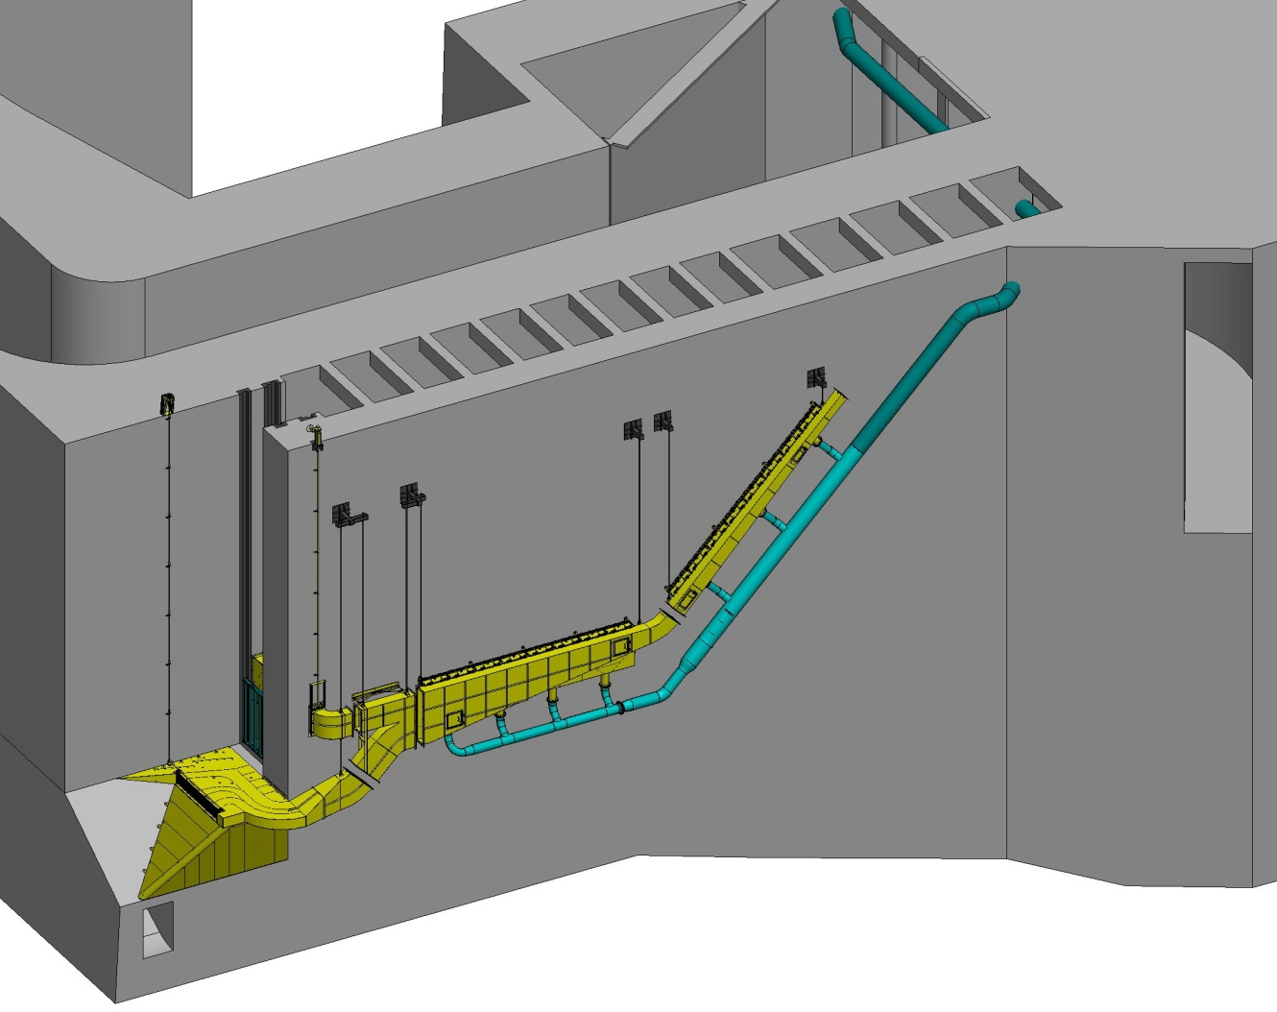
LPS and LFS junction. University of Idaho is installing LPS components on the tailrace deck, with assistance from the contractor.

Figure 1. 3-dimensional rendering of the Lamprey Flume System (LFS) with gravity flow water supply system. During the proposed extended IWW period, COE currently expects to complete the entire system shown here, in addition to the Lamprey Passage Structure (LPS) that connects to the upstream section of the LFS (circled, see Figure 3). If the LFS is not completed by March 11, sections would be capped to prevent fish access during passage season.

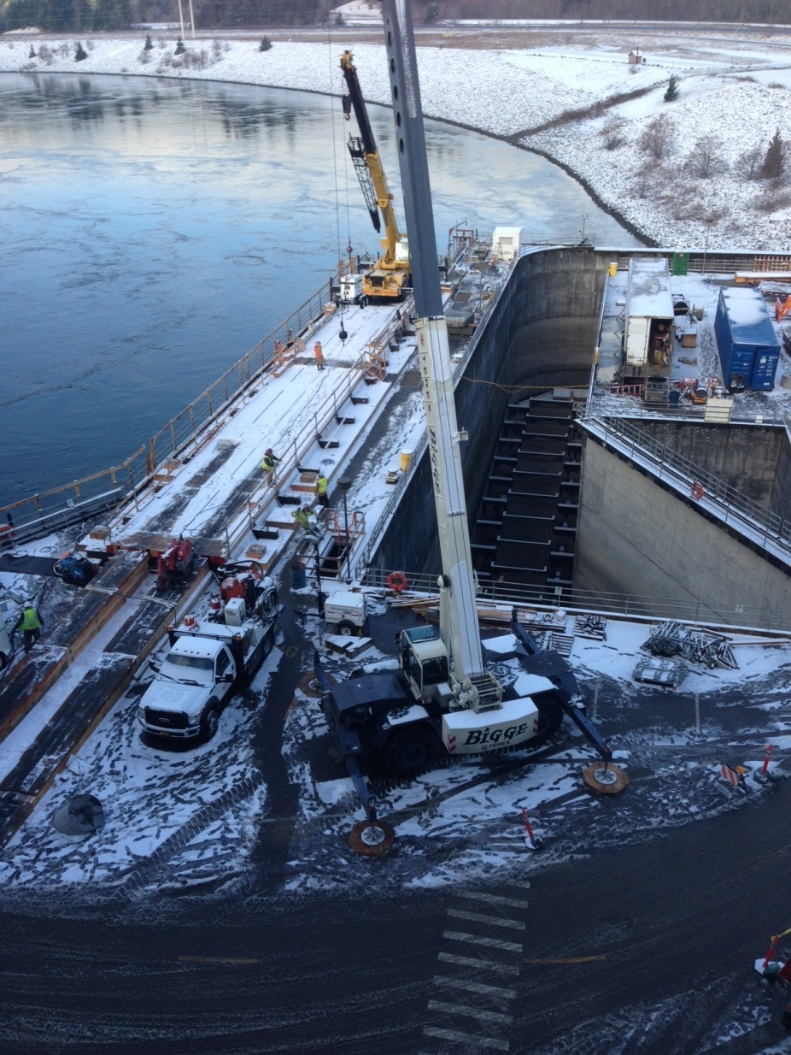

Figure 2. Photo of LFS construction activity at the Bonneville Washington Shore Fish Ladder. The yellow crane is situated on top of a temporary platform that covers the North Monolith transportation channel between NDE and NUE (outlined in red). During the proposed IWW extension, this platform and crane would remain in place and operating, while the fish ladder is in service (SUE and SDE open).

LPS and LFS junction. University of Idaho is installing LPS components on the tailrace deck, with assistance from the contractor.
LPS lamprey holding tank at terminus of LFS-LPS system. This is located at the end of the North Downstream Entrance (NDE) roadway deck.

Figure 3. Lamprey Passage Structure (LPS) to connect with Lamprey Flume System (LFS) at Bonneville Washington Shore Fish Ladder. Tailrace deck construction activity after March 10 may include installation of some LPS components shown here. The LPS crosses the fishway, then runs along the railing (difficult to see here) to the end of the monolith, where the system terminates in a mobile holding tank.

Table 1. Passage of adult salmonids at Bonneville Dam from March 1 through March 15 (2004-2012 counts).

Passage at Bradford Island Fish Ladder (March 1-15)
Year | Chinook | Steelhead | Ladder Total | BON Total | % of Total BON
2004 | 41 | 262 | 303 | 830 | 36.5%
2005 | 11 | 24 | 35 | 89 | 39.3%
2006 | 0 | 100 | 100 | 479 | 20.9%
2007 | 10 | 345 | 355 | 748 | 47.5%
2008 | 27 | 102 | 129 | 399 | 32.3%
2009 | 20 | 71 | 91 | 153 | 59.5%
2010 | 25 | 313 | 338 | 1015 | 33.3%
2011 | 22 | 192 | 214 | 443 | 48.3%
2012 | 8 | 302 | 310 | 702 | 44.2%
Mean | 18 | 190 | 208 | 540
% Mean Passage |  |  |  |  | 40.2%
Passage at Washington Shore Fish Ladder (March 1-15)
Year | Chinook | Steelhead | Ladder Total | BON Total | % of Total BON
2004 | 119 | 408 | 527 | 830 | 63.5%
2005 | 7 | 47 | 54 | 89 | 60.7%
2006 | 1 | 378 | 379 | 479 | 79.1%
2007 | 12 | 381 | 393 | 748 | 52.5%
2008 | 16 | 254 | 270 | 399 | 67.7%
2009 | 5 | 57 | 62 | 153 | 40.5%
2010 | 18 | 659 | 677 | 1015 | 66.7%
2011 | 16 | 213 | 229 | 443 | 51.7%
2012 | 9 | 383 | 392 | 702 | 55.8%
Mean | 23 | 309 | 331 | 540
% Mean Passage |  |  |  |  | 59.8%

Figure 4. Mean daily steelhead (black bars) and Chinook salmon (gray bars) passage at Bonneville Dam in March (2004-2012).

